Digitizing the Fourth Wall

Broadway 2030

Imagine a world where you attend a Broadway show any day of the week, at a price you can afford, from anywhere across the globe and have the best seats in the house. Now imagine that the community of artists, producers and crew members who create this experience have unified to craft an ecosystem of equality where all make a living wage and issues such as disability, sexual orientation, gender, and race inequity have been reduced to a case study in the history books. Imagine that world where we celebrate rich, diverse stories accessible to everyone, inspiring generations to come in elevating humanity.

A 2,000-year-old Business Model

Since the very first plays took stage at the Theatre of Dionysus in the fifth century BCE, the theatrical business model remains essentially unchanged. Thousands of shows vie for one of the 41 Broadway theatres, of which only around 20 become available each season after already spending five to ten years in development and millions of dollars navigating physical resource constraints, gatekeepers, and systemic challenges. Of those that survive the journey, only a few breakouts ever recoup their investment and even less make a profit, as up to 85 percent lose most or all of their investment. This creates a system where only an elite few see any financial gain, which leads to new voices and stories never being seen, heard, nor shared.
The model follows a traditional linear path where artists create works on spec, then search for a producer to secure funding. The producer aligns investors to begin the process of readings, labs, workshops, and regional productions to guide the story’s development in the hopes of the show eventually landing a first-class commercial production on Broadway or the West End in London. This process ranges from 5 to 10 years with up to $35 million dollars spent over the lifespan of the work. If a show fails to make it to opening night on Broadway, then investors likely lose most, if not all, of their investment.
While the model has stagnated, the risks and costs of producing untested new works and voices have exponentially escalated. 13 separate Broadway unions maintain jurisdiction over 41 Broadway theatres largely controlled by only three owners. In today’s Broadway ecosystem, a show needs between $500,000 to $1 million in ticket sales each week simply to keep the doors open. This means most shows must run at full capacity to just break even. Often, only the shows that demand premium ticket prices can survive in the long run and make a profit. Instead of creating opportunity for new stories, this system only works for established brands and corporations with deep pockets.
Flash forward to today as the theatrical industry reboots after 18 months of shuttered venues. All the traditional financial and physical challenges remain and, in many cases, have risen, yet the consumer purchasing models for live theater contain so many new and changed variables that worsen an already fragile financial ecosystem. This, coupled with the demand for more equitable content, compels creative teams and leaders to seek new ways to develop, produce and deliver an artform that elevates humanity.
Introducing BroadVerse
While the current challenges may seem insurmountable, we envision a version of Broadway where we shatter the gatekeeper mechanisms to create a vast new ecosystem of fresh stories, voices, and audiences; where you can either attend a show live in a physical theater or find a similar human connection virtually from your own physical space with easily accessible and comfortable technology. Although this may seem futuristic, the intersection of foundational technologies has crossed the exponential growth point. With over 60 years of combined experience in live theater, film, and technology, we unify our vision for the future to launch BroadVerse.
To understand BroadVerse, we first define the broader application of Web 3.0 and the Metaverse. Web 3.0, Web3 and W3 all focus on evolution and iteration of the World Wide Web based on a decentralized blockchain technology utilizing user driven token-based / Crypto economics. The word "Metaverse" combines the prefix "meta" (meaning beyond) and the stem "verse" (derived from "universe"); the term coined by Neil Stephenson in his novel Snow Crash, typically describes the concept of a future iteration of the internet, made up of persistent, shared, 3D virtual spaces linked into a perceived virtual universe [1]. The metaverse in a broader sense may not only refer to virtual worlds, but the Internet as a whole, including the entire spectrum of augmented reality.
You may ask: what does this have to do with live singing, dancing, and standing ovations? Everything! In the same way the music industry was revolutionized by digital distribution, or the film industry shifted due to in-home television systems and streaming services. In both cases, technology radically altered the path from artist to audience. Before digital content and shareable platforms artists relied on approval from gatekeepers (such as record labels or Hollywood studios) for their work to be realized. Today, these same artists can share a song or make films as easily as ever, with the ability to choose from a myriad of platforms such as YouTube, TikTok and Instagram – all while the record companies and film studios still create successful content. We envision a similar balance for theater.
Defining BroadVerse
- BROAD: Stems from “Broadway in the Metaverse”, but also for the literal meaning of “BROAD.” Rather than a linear seven-year journey from idea to stage, we begin in years one and two with monetizable intellectual property and assets that can be shared across existing platforms such as film, stage, and audio outlets. These same assets can begin exploration into the Web3 world of social tokens, community evangelism and NFTs.
- VERSE: Signifies our commitment to the foundations of the Metaverse, Oasis, Omniverse or whatever it may end up being called. The term also builds on the proven business practice of the story UNIVERSE. Brands connect emotionally with audiences at all levels. Ultimate entertainment brand examples include Marvel, Lucas, Pixar, DC, etc., however smaller brands can leverage the same audience and emotional connection, as proven by influencers across YouTube, Instagram and TikTok.
Thus, our BroadVerse model accelerates new stories, voices, and thematically diverse theatrical content to reach audiences sooner while empowering fans to actively engage in the developmental process. By shrinking the developmental timeline, costs and risks while using revenue streams and audience engagement to collect data on a new work’s future potential, the potential audience size massively expands way past one physical theater.
For the past six years and for the coming decade we have and will contribute to the foundational infrastructure of the “Metaverse” version of theater by designing the creative language and systems through processes, tools, and integrations. We create the blueprints and products for artists, investors, and audiences to share in these deeply human experiences.

Metaverse Hedge Fund: All About the Timing
For those riding the AR/VR/MR/XR/?R roller coaster for the last 25 years we can’t help but feel like we should be singing the classic song by The Who, “Won’t Get Fooled Again”. Every five years we say, “We are five years away.” Even Gartner’s hype curve diagram has XR technologies bouncing all over the place. In the past we recognized that many technologies needed to align to create a healthy ecosystem, but those of us who have experienced the deep human connection of XR underestimated the complexities and related variables when estimating widespread consumer adoption.

While new realities and the Metaverse have seemingly been on the horizon for over 25 years, many barriers have fallen in the past 24 months. Today, we have a burgeoning XR community that, while still in its infancy, shows signs of becoming one of the biggest markets since the dawn of technology. The barrier to hardware plummeted with Facebook’s Oculus Quest line taking the costs of a headset and PC from roughly $3000 to a standalone $300 device. More importantly, Meta’s (formerly Facebook’s) commitment to the Metaverse as the company’s future not only brings massive resources, but also raised the bar for industry competition. The top technology companies all have a vision for their future in the Metaverse, including Microsoft and their Mesh initiative, Nvidia’s Omniverse, Roblox, Epic and Unity’s tools and platforms, and forthcoming products from Apple, Amazon, and other key vendors all lead to a competitive ecosystem ushering in rapid innovation.

This begs the question, “When can we start?” The answer is now(ish). From a consumer standpoint, multiple forecasters estimate this to be a trillion-dollar industry in the next 10 years. However, we have all seen these numbers and remain skeptical on when XR reaches ubiquity at levels matching cell phones or the internet. That creates the (ish) part of our equation and validates our reason for not placing all our non-dairy eggs in that mesh basket.

Currently, the maximum virtual experience sits around one hour for an audience member to comfortably enjoy in a headset. That dictates shorter form content for now. However, like all technologies, headsets will become lighter, faster, and more personalized. Therefore, we embrace the constraints for building today with our eye toward the future. More importantly, the same assets we build for the XR experience can be used today for live stage productions, films, games, audio recordings and many more. By using XR developmental techniques, gaming engines (Unity and Unreal) and partners in the virtual space we simultaneously develop stories and create valuable assets which serve both the creative and financial process. We build XR experiences using today’s technologies while designing for a more robust and human connected 3D experience.
As discussed before, the current model for theatrical development relies on a massive amount of physical infrastructure and assets, large amounts of capital and five to ten years to simply understand product market fit and brand. Not only can we shrink the time, cost, and risk of new works, we can grow the brand, assets and data while bringing new voices and stories to light. We can shrink what would normally take seven years to three years or less all by utilizing what exists today.

HOW: MVP to Monetization
In this section we look at the traditional theatrical process and compare the BroadVerse approach through the lens of XR to overlay the aforementioned benefits.

Traditional Broadway
As mentioned, the current linear path to Broadway has long been the industry standard. This process, of course, begins with an idea or concept. Once the writers have generated enough content, the show progresses to a reading, then on its feet with a lab or workshop, then generally will mount a full production at a theater away from New York City before finally getting to Broadway. Progressively in each phase, the number of shows that can get to the subsequent stages shrink as the price increases.

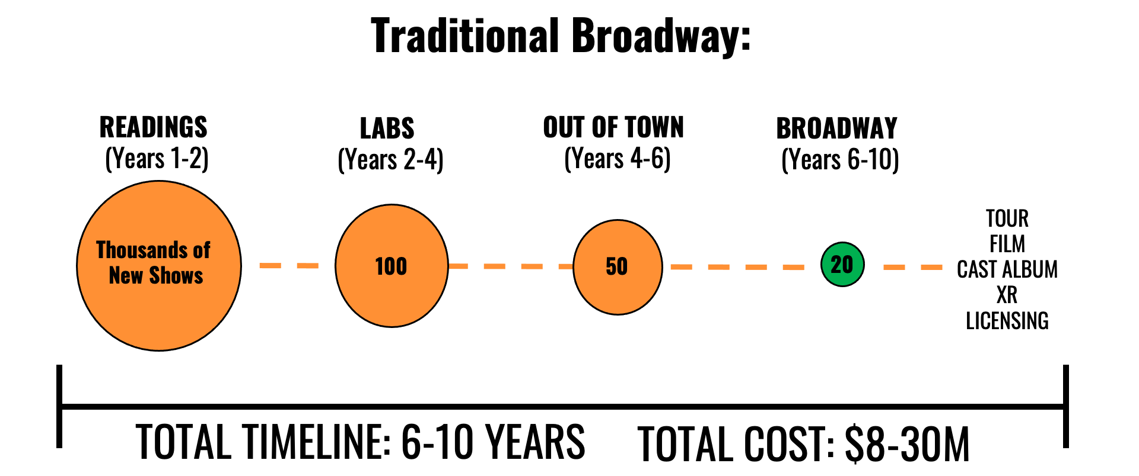

- Readings (Years 1 – 2)
Traditionally, new works follow the initial 29-hour reading process. The 29 hours refers to the amount of time you can work with Equity actors. The original intent was to give time to the authors to see and hear their work aloud and to quickly iterate changes. Over the years, these have morphed to backers’ auditions and most of the time goes towards perfecting the presentation. Although useful for potentially bringing on investors, it currently serves as the first and, in some cases, insurmountable barrier for new works. Authors/Producers need to raise anywhere from ten to fifty thousand dollars to cover the costs of a proper reading.
- Labs / Workshops (Years 2 – 4)
During the lab / workshop stage, producers, and the creative team stage a minimal version of the show focusing on “seeing the show on its feet” without the use of sets, lights and fully realized costumes. Originally designed to focus on the creative process at minimal cost in order highlight the story, staging and choreography, the rising cost structure hampers the creative opportunity in favor of raising more money for the next step. An average lab / workshop in New York City costs between $300,000 – $600,000 for six weeks of work. The process culminates in a presentation for a small group of investors who determine if the show moves to the next step. If not, all time, money and creative development disappear.
- Out of Town (Years 4 – 6)
At this stage, the show receives additional backing, “enhancement funding,” to be mounted outside of Broadway in what is known as an “out of town” tryout. Producers pay one to three million dollars to a regional theater to produce the work in hopes of gaining strong reviews which lead to additional investment. If the show fails at this stage, all investment usually disappears with the investors owning nothing moving forward. Even if the show becomes a critical success, the amount of measurable data relating to Broadway purchasing patterns remains limited to the demographic of the regional theater. While an important step for the progression to Broadway, we see a much more optimized approach if or when a show embarks on this step.
- Broadway (Years 6 – 10)
Good reviews and additional investments from the out of town try out help to secure a possible Broadway Theater. As mentioned, only about 20 slots per year open on Broadway for new shows as many long running shows such as Hamilton, The Lion King, Wicked and Phantom hold on to their theater for years. Of the shows that make it to Broadway, around 85 percent end up failing to recoup their original investment. Producers and investors sometimes find additional revenue through touring productions, filmed productions, cast albums and licensing – after the show has already finished the Broadway run but rarely enough to recoup the initial investment on Broadway.

The BroadVerse
Instead of looking at the linear approach for stories, we use virtual tools and existing technologies to design and build our Metaverse version of the show. We look to develop the lights, sets and costumes while simultaneously developing the story. Those same assets can be used in the Metaverse, but also as templates and baselines for film and stage today (for example, TV shows like The Mandalorian are using similar concepts to create their virtual sets). Ultimately when the Metaverse appears in full force, we will have a stockpile of content already created.
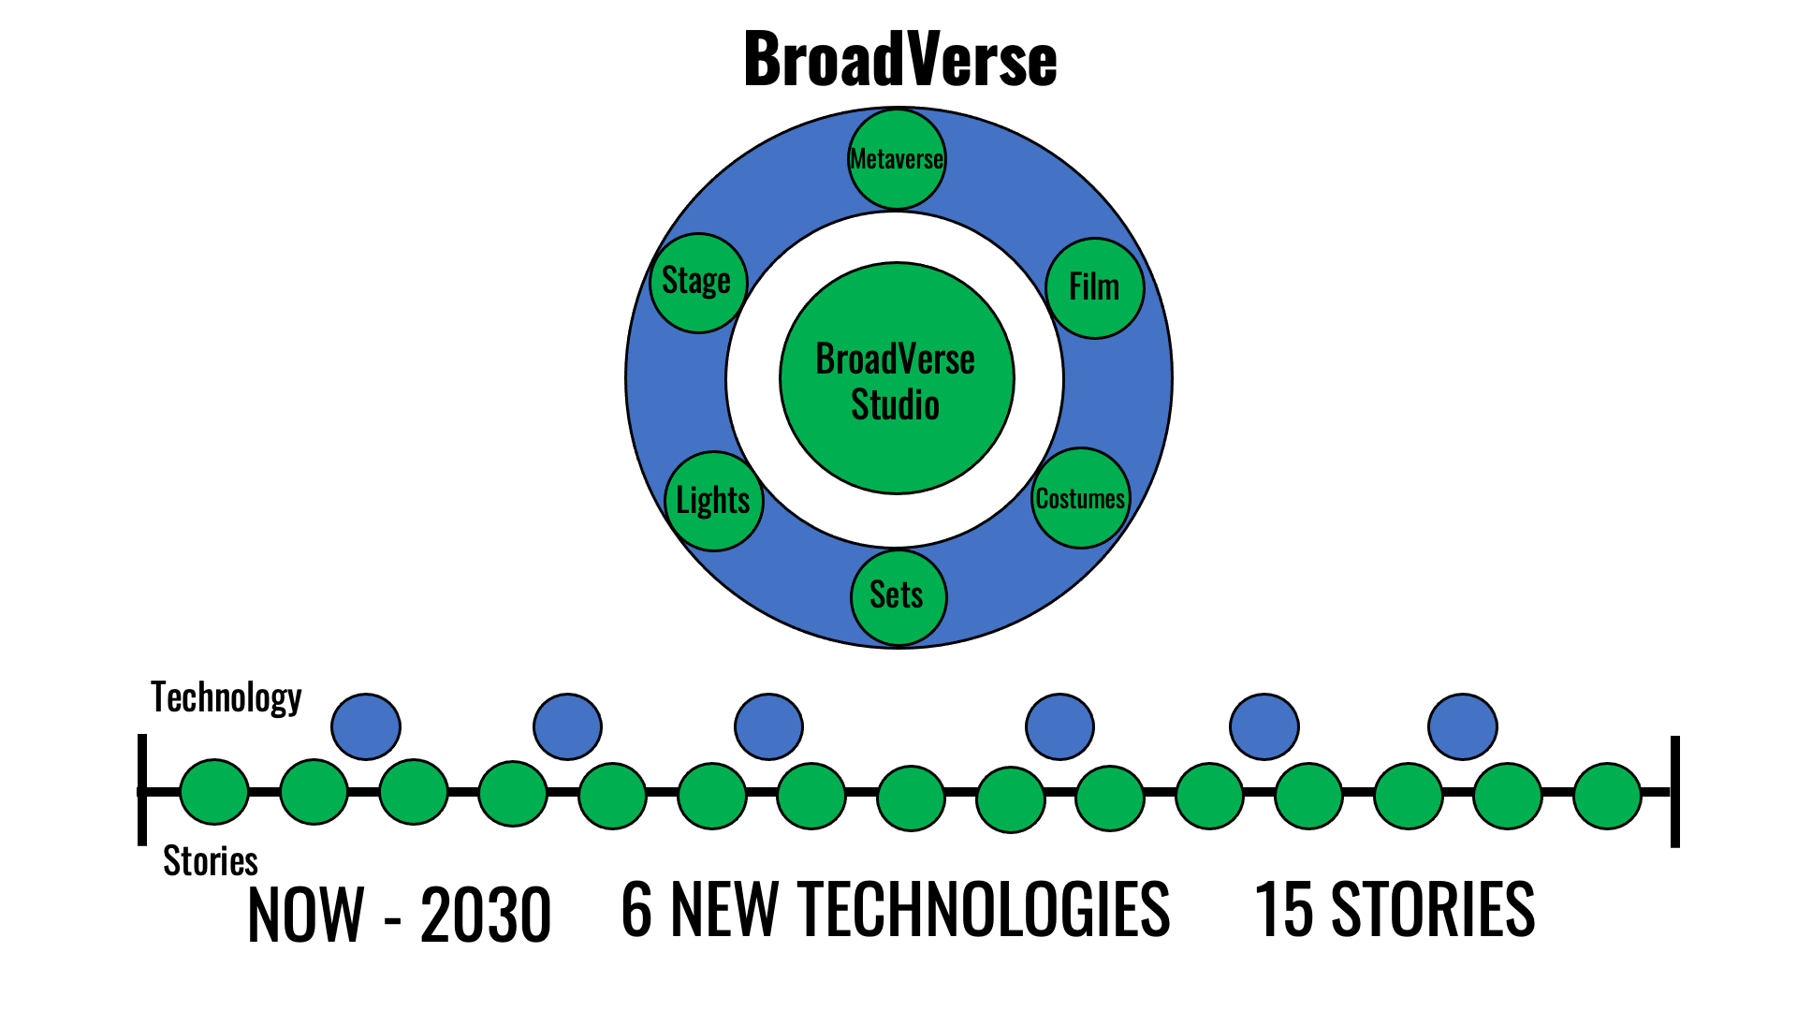
- BroadVerse Story Development / “Readings”
Although the pandemic forced colleagues to adopt a digital development strategy, we have been using technology at this stage since 2017. Through a mixture of 2D development using Zoom and 3D off the shelf worlds through already existing platforms like AltspaceVR, we give time to creating a solid artistic foundation. This cuts travel, rehearsal space rental and many other costs while keeping the focus on the artistic process. We strongly believe the period requiring the heaviest investment of time should be creative development.
- Getting The Show on its Virtual Feet
Using the XR development engines Unity and Unreal, we rapidly prototype each show in Virtual Reality utilizing a combination of free/cheap assets (sets, costumes, props, lighting, sound and VFX) combined with custom in-house developed show specific assets. Through continuous iteration, we focus on the story and tone at a fraction of the costs of traditional methods. If we deem the project worthy to move forward, we define and create reusable “hero” assets while developing the project plan for the next phase. If we chose not to move forward, we would have spent less than 20 percent of the budget and time as the current model while continuously refining our process. Through a mix of current practices and XR technologies combined with our inhouse techniques and tools, we further the development of the show and expand our new processes while building supporting tools that we may use as proprietary technology or license to other creators.
- Out of This World
Building on the previous XR phase, we now create production ready assets using the same XR engines and continue development on our process and tools. For example, instead of building physical sets we create high quality virtual sets, lighting, sound, costumes, props and SFX/VFX assets using the same XR engines as in the previous phase. We then run the show or portions of the show virtually to gather audience data and refine the environment. As the Metaverse evolves, our “out of town try out” becomes an “out of this world try out.” Until then, we continue to build and bank these assets which also work in traditional distribution mechanisms. For example, that same virtual set can become the backdrop on stage using existing volume technology for a film. The music and script become albums and podcasts and so on. Instead of waiting seven years and crossing our fingers that we have a good show after spending 20 million dollars we begin releasing in year two to cultivate the audience while continuously building the brand.
- Continually Building the Audience & Brand
In year two or three, we jumpstart the audience engagement to raise awareness and generate revenue. While we pioneer Broadway in The Metaverse as a content provider and thought leader, we also leverage partnerships for streaming, stage, licensing and NFTs. A multipronged approach builds on an immediately available distribution infrastructure desperately seeking content while raising the overall brand value for future endeavors. Once the Metaverse becomes viable for comfortable full productions, we become an immediate XR story leader.
By using commercial properties and partnering across multiple existing distribution points such as stage, screen, print, digital and licensing we can lead the charge in building the forthcoming BroadVerse where we can attend a live show anywhere in the world from our home and feel the human connection of sitting in a live theater. Rather than all or nothing, we see it as everything and beyond.

 | Traditional Broadway | BroadVerse
Reading | Low Cost  Minimal Audience Reach  No Reusable Assets | Minimal Cost  Branded Audience Reach  Some Reusable Assets
Lab / Workshop | High Cost  Some Audience Reach  No Reusable Assets | Marginal Cost  Branded Audience Reach  Some Reusable Assets
Out of Town | Higher Cost  Local Audience Reach  Some Reusable Assets | Fractional Cost  High Audience Reach  All Assets Reusable
Broadway / Final Iteration | Maximum Cost  High Audience Reach  Varying Reusable Assets | Fractional Cost  Maximum Audience Reach  All Assets Reusable

The End of Live Theater?
Usually at this point in our discussion, someone crosses their arms and says something akin to; “Are you trying to kill live theater?” or “The whole reason I go to theater is for the live human connection.”

This same argument was debunked when pundits predicted that bands would never tour again once music videos became mainstream. The opposite occurred as in other cases where digital increased the desire and price for live experiences. An overwhelming amount of data supports the fact that digital aids rather than detracts from the desire to experience a show or event live. A perfect example stems from the recent Super Bowl, where 110 million people watched the broadcast digitally while 75,000avid fans paid $5,000 to over $100,000s per seat for the live event experience. Rather than arguing the merit of one over the other we chose the answer “E”, all the above.

Second, we agree that for most theatergoers the current digital representations, even ours, do not replace the experience of seeing a show live on Broadway. Thus, we focus on crafting the content to natively embrace traditional entertainment distribution such as stage, screen and headphones while simultaneously developing for the future. XR technologies can currently create that sense of presence and human connection that so many seek but we acknowledge that we need more time and investment to evolve the human experience in XR. Just as film started by adapting a stage experience with a single camera then evolved to create a robust set of storytelling conventions using sophisticated camera movement, lens choices and editing, we see the next years as a critical time in pioneering the language of theater in XR. Most importantly, we see all these advances as a reinforcement for, and an enhancement to, the live experience.

Broadway 2030
We close as we began by looking towards the future as we celebrate a love for the theatrical artform. BroadVerse both imagines and creates worlds where you can attend a Broadway show any day of the week, at a price you can afford, from anywhere across the globe and have the best seats in the house. As you enjoy these deeply connected experiences, rest assured that the community of artists, producers and crew members who create these moving stories have unified in an ecosystem of equality and positivity. By the year 2030 we should all proudly look back to now as the inflection point that, through XR technology, moved humanity closer together.

